Problem Statement 4: How to Load Multiple Files in Parallel in Azure Data Factory.

In Azure Data Factory, a dataset describes the schema and location of a data source, which are .csv files in this example

* I downloaded the two .csv files, the first with the comma as delimiter and the second one with the semicolon as delimiter of which I can still use the same dataset as I only need to put a parameter on the definition of the delimiter.
* I created a metadata table using the key-value pair method which allows me to store any type of metadata in the table.
* I created the metadata table in SQL Server and also created parameterized datasets in Azure Data Factory. I then combined both to create a metadata-driven pipeline using the ForEach activity.
* I used the Lookup activity to retrieve the metadata
* While running the Query, I forgot to deselect the first row, and I got errors. I went back to deselect it and got back on track.
* While creating the sink, I had to specify the parameter value for the table name using the expression: @{item().SQLTable}
* . In the Pre-copy script field, I also specified an expression that will truncate the destination table with the following expression:
* TRUNCATE TABLE [dbo.@{item().SQLTable}](mailto:dbo.@%7bitem().SQLTable%7d)
* I then validated, debugged, published and triggered my metadata pipelines which I monitored to make sure they all succeeded.

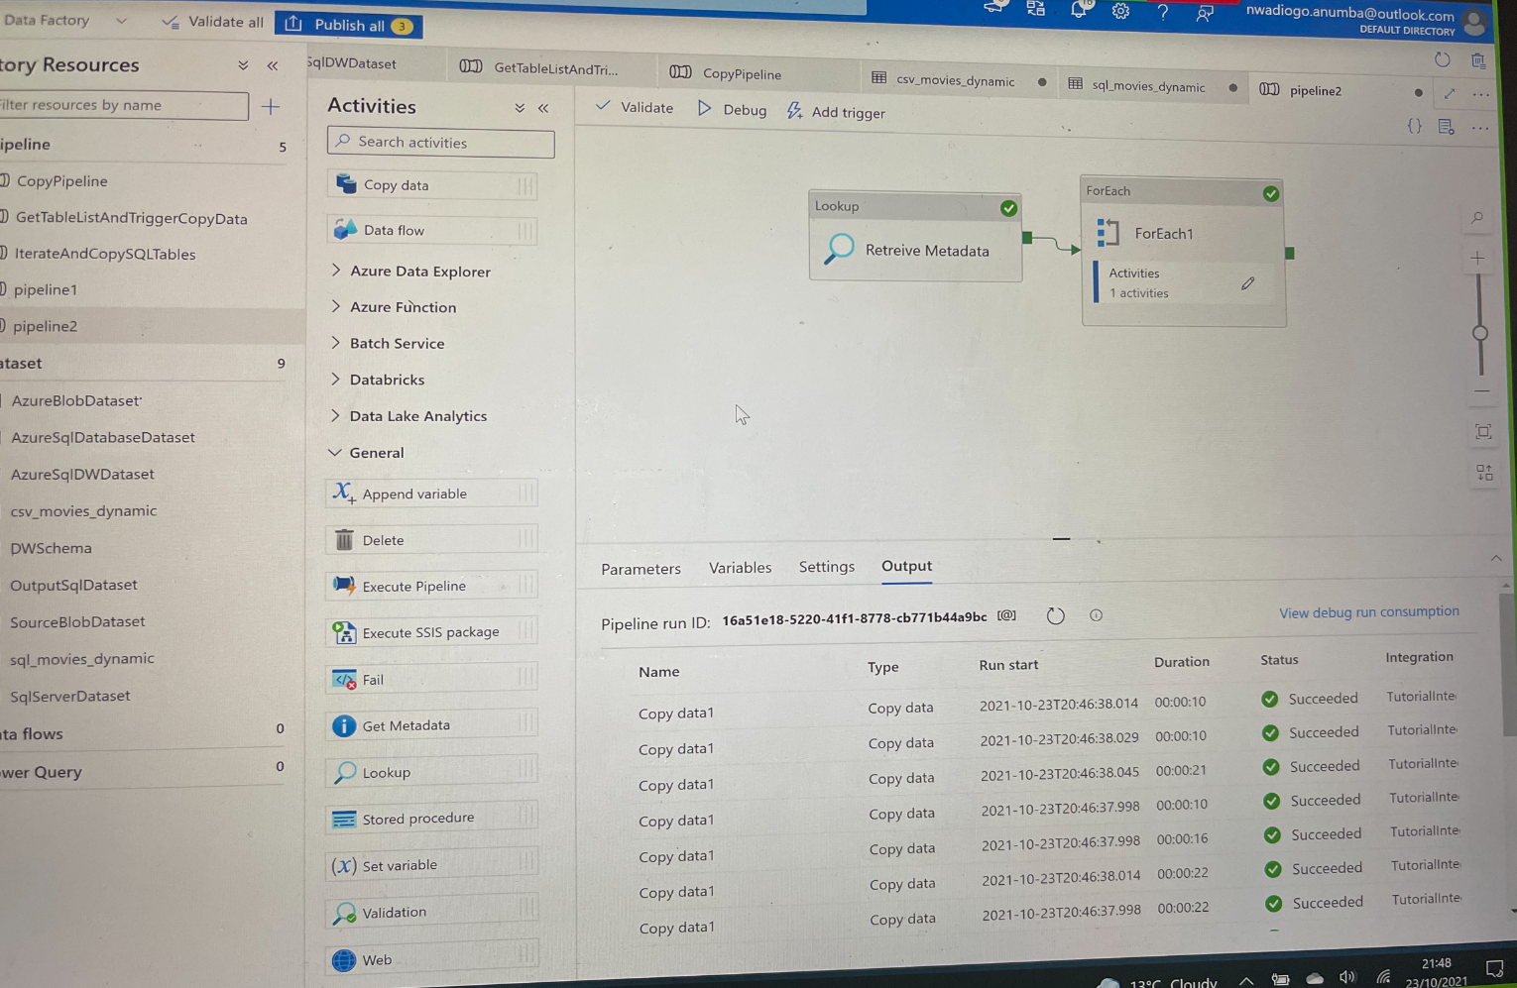

Figure 1: Succeded pipeline runs